National Centre for Human Settlements and Environment (NCHSE), in collaboration with Consumer Voice, New Delhi, joined hands with Ankur Higher Secondary School, T T Nagar, Bhopal, to organize a road walk and human chain on November 22, 2023, in honor of the "World Day of Remembrance for Road Traffic Victims.

Sandhya Prakash
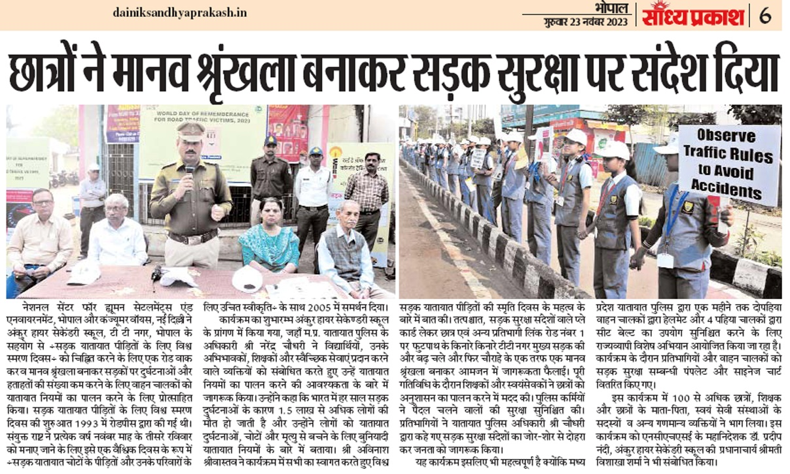
Swadesh
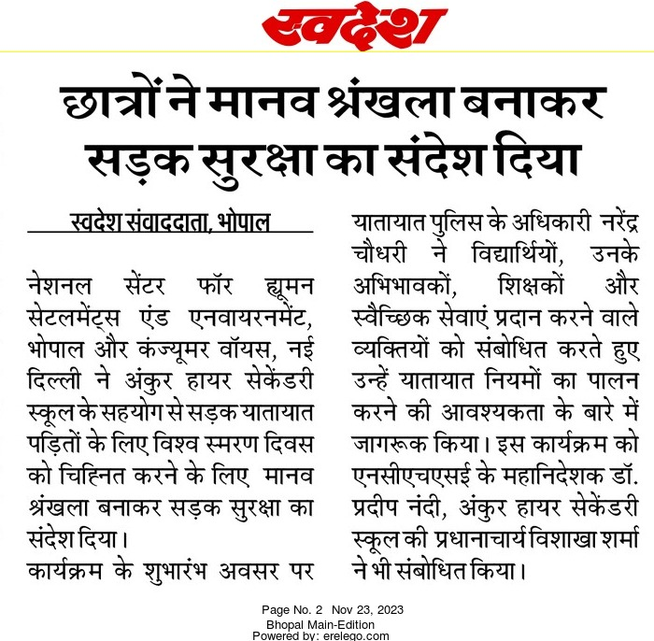

Jankalyanmail

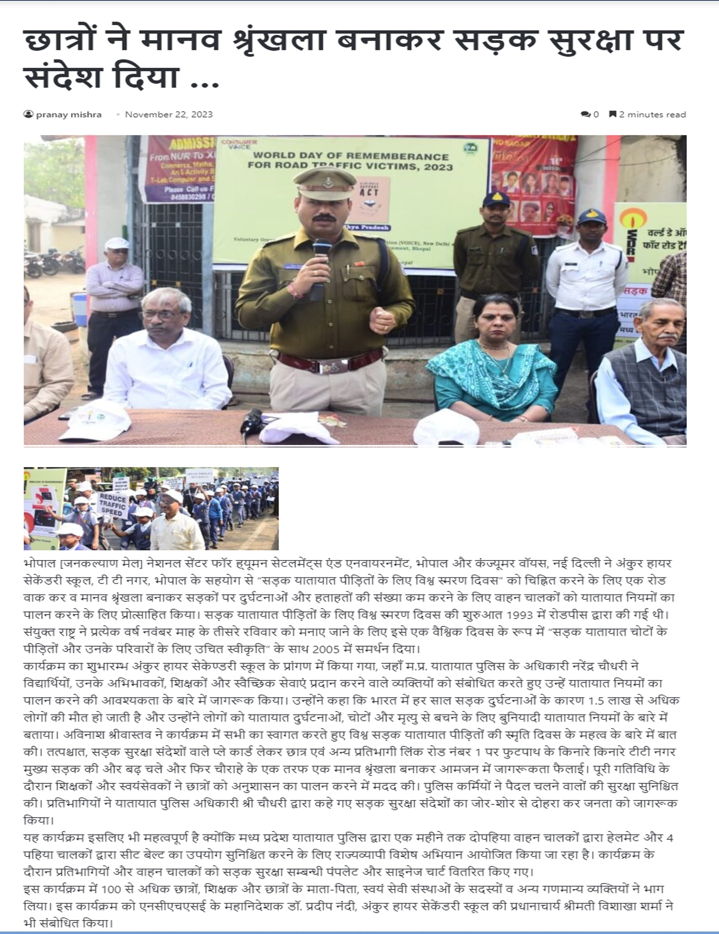

Raj Express

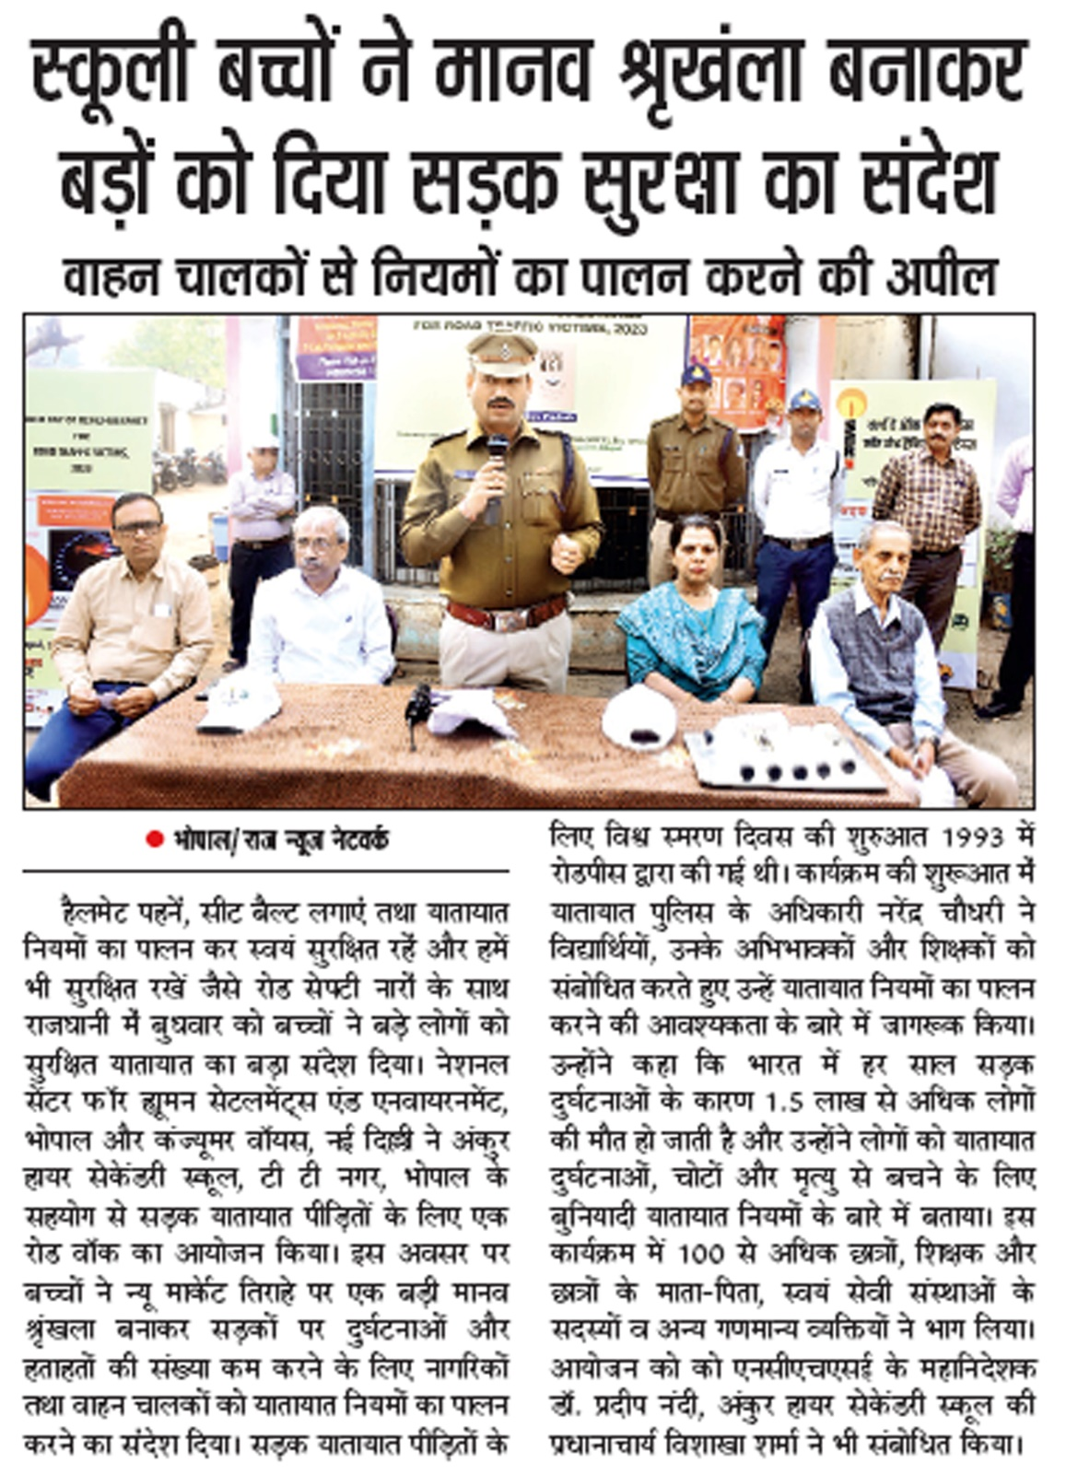
Patrika-news
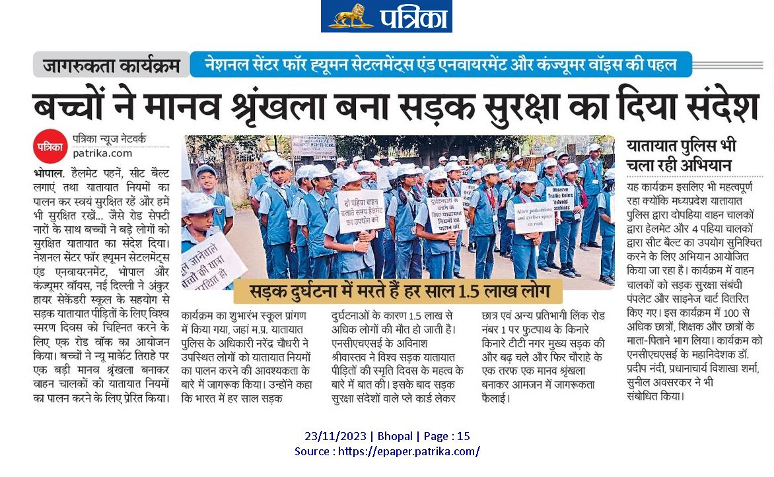
People’s Samachar
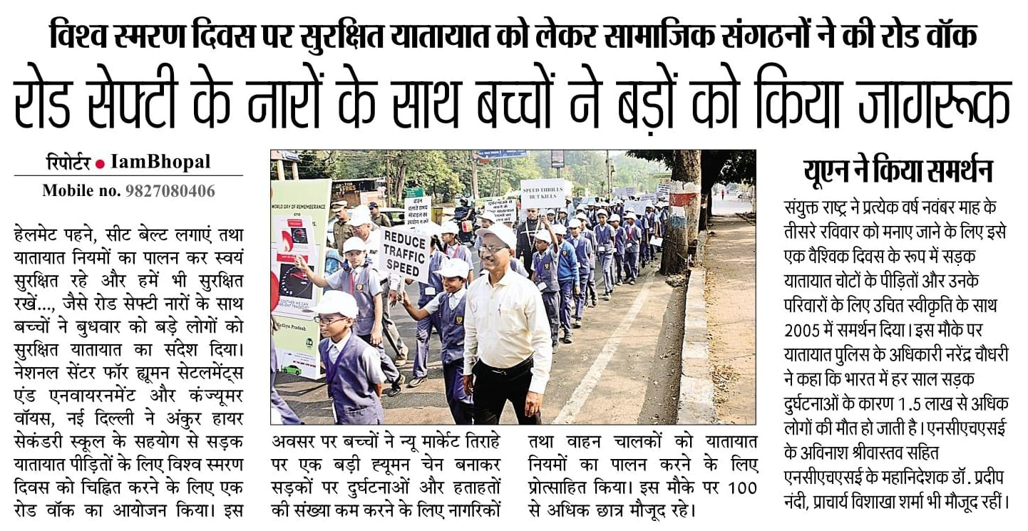

Navduniya
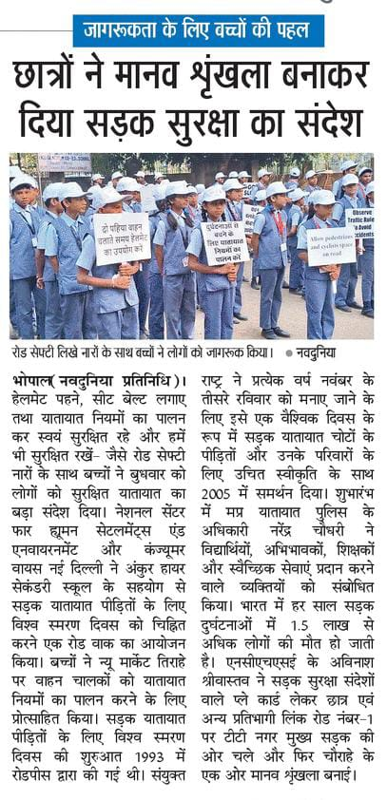

Jagran
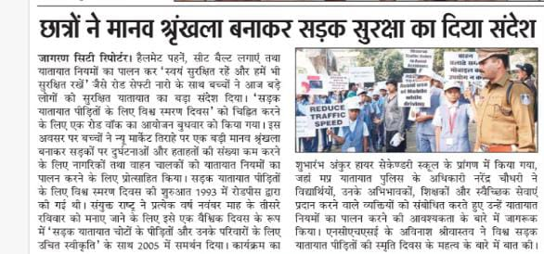
CNN central news
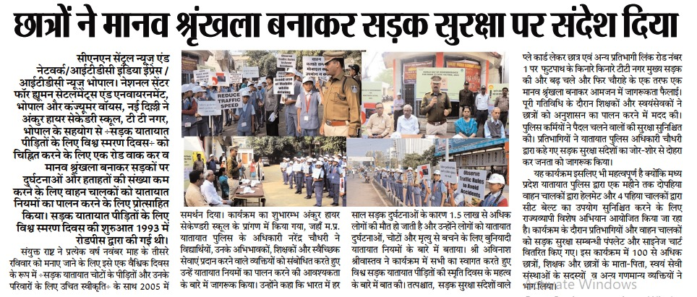

Freepress
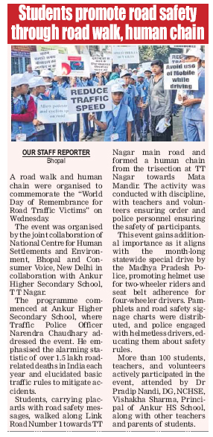

E-lokottar-in
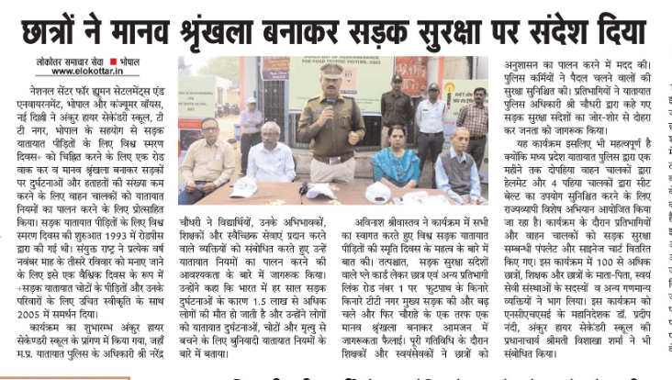

Dainik Bhaskar
