To commemorate the World Day of Remembrance (WDR) for road accident victims in 2023, Consumer Guild, in collaboration with Consumer VOICE New Delhi and with active support from Traffic Police Lucknow, organized a tribute meeting (Shradhanjali Sabha) and a cycle rally.

GHATNAYEIN
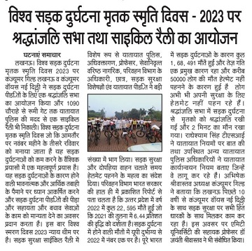
SHERE BALIA

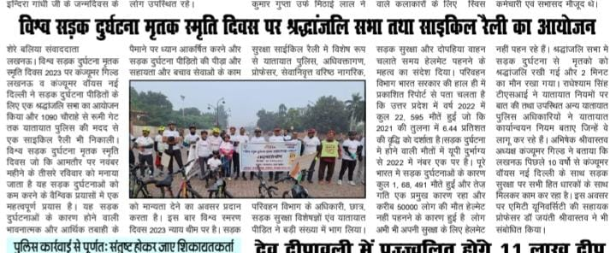

SARITA PRAVAH BUREAU

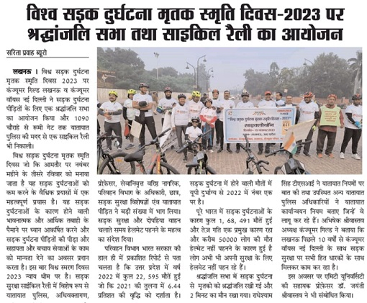

LOKBHARTI NEWS BUREAU

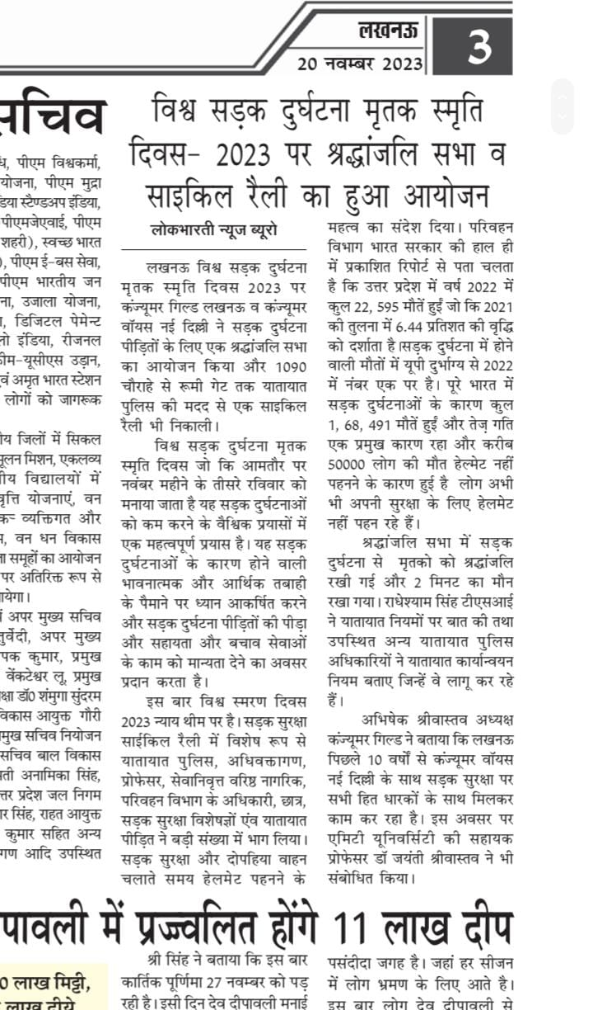

KANWEEZ TIMES

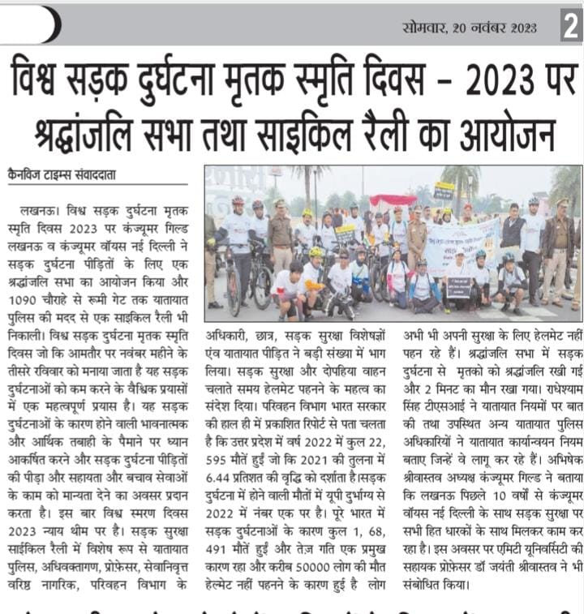

DAILY NEWS ACTIVIST-EK NAZAR

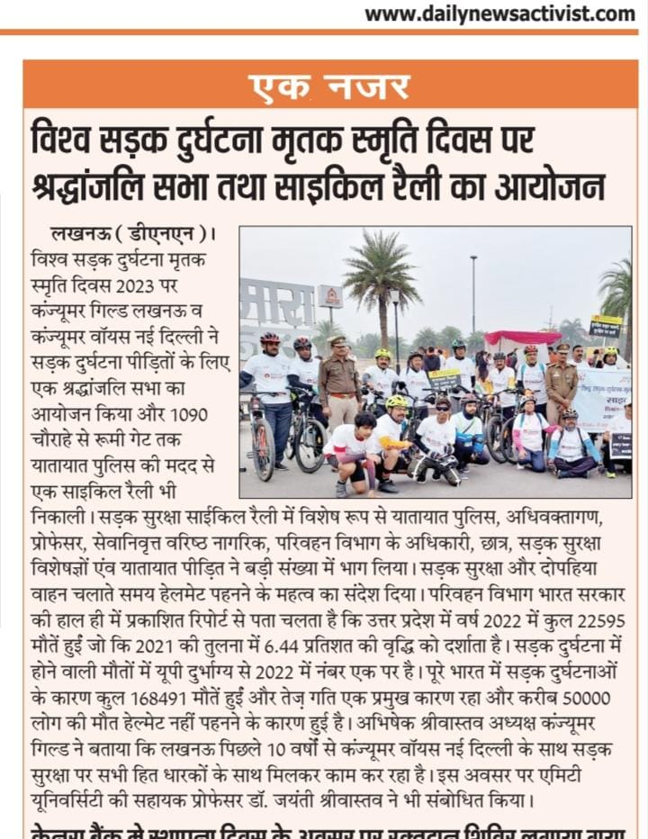

VOICE OF LUCKNOW

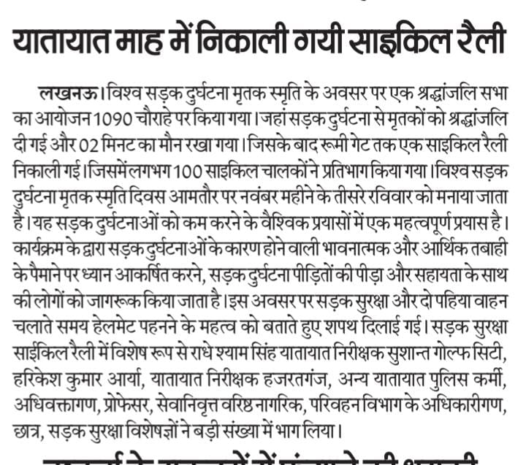

RASTRIYA SAHARA
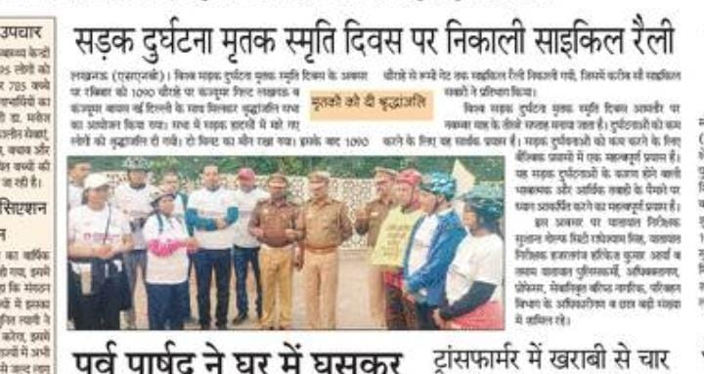

HIND WATAN
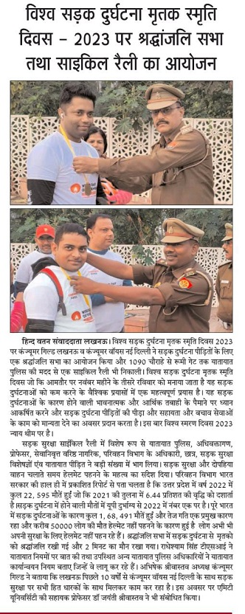

AMAR UJALA

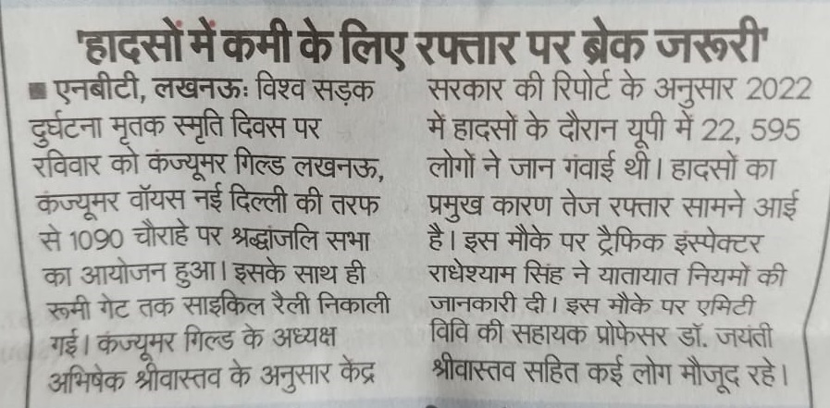

INQUILABI NAZAR

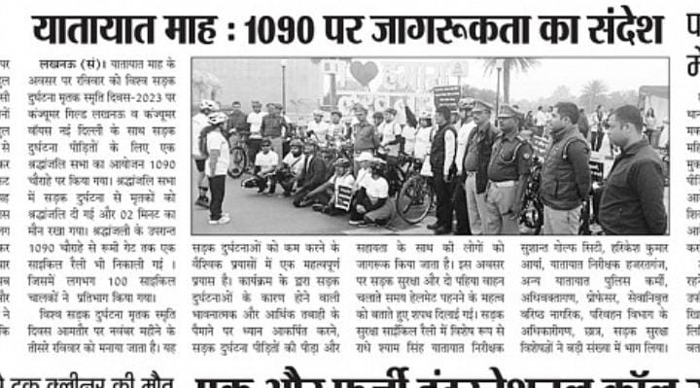

Awaz Plus Desk

