AAJ

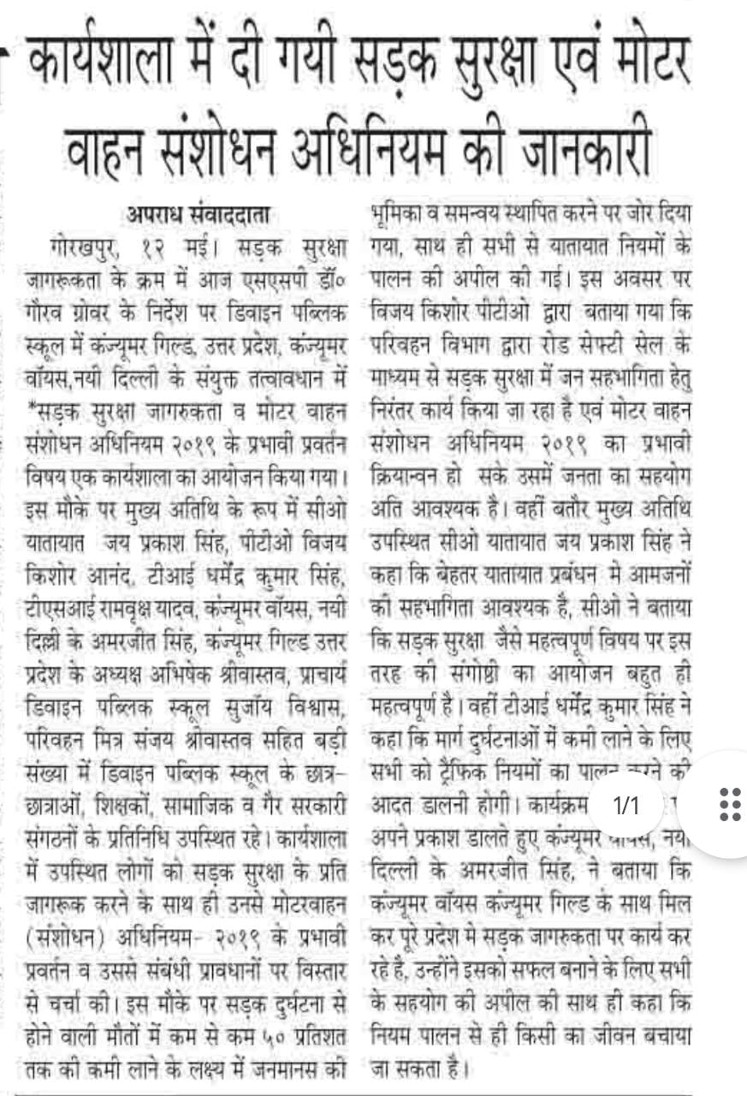
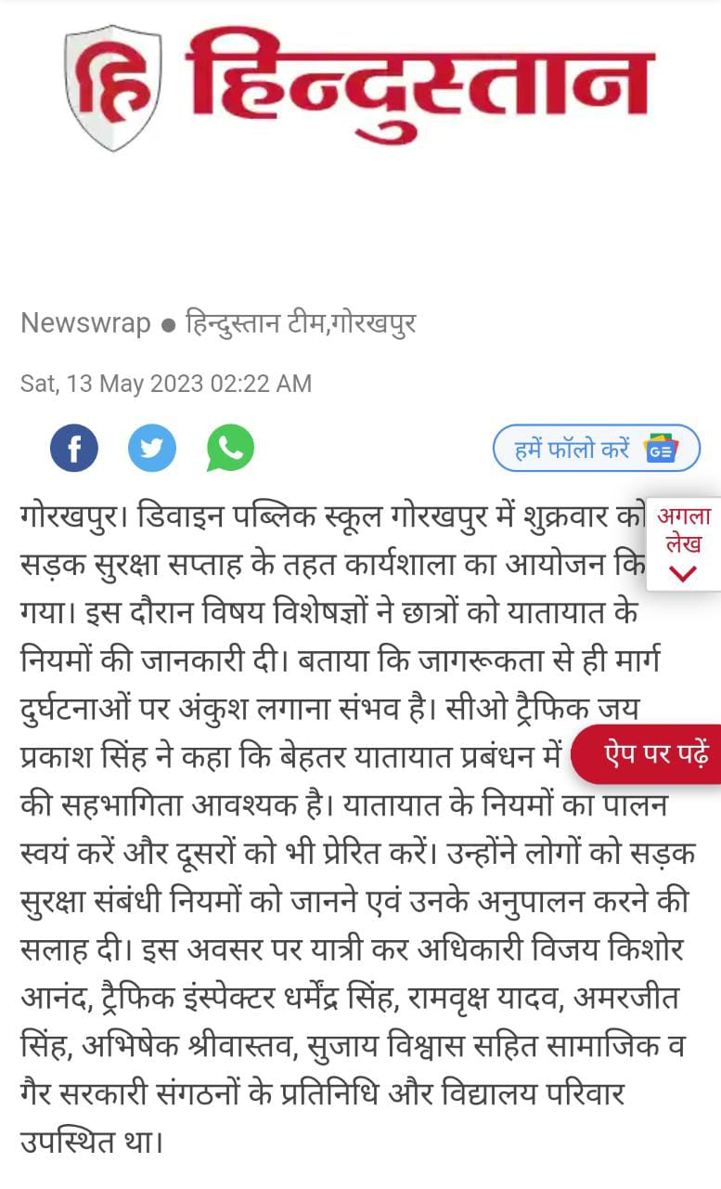 HINDUSTAN

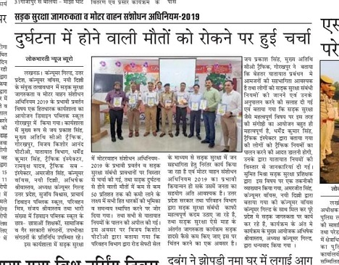
LOKBHARTI NEWS BUREAU

http://m.rashtriyasahara.com/imageview_6316_117466542_4_6_13-05-2023_7_i_1_sf.html

RASTRIYA SAHARA

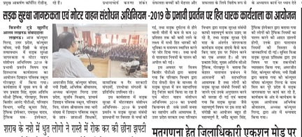

BIJNAUR TODAY

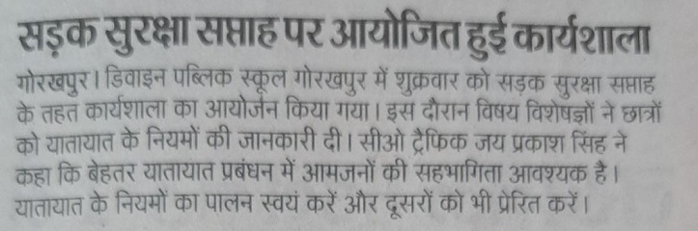

DAINIK JAGRAN
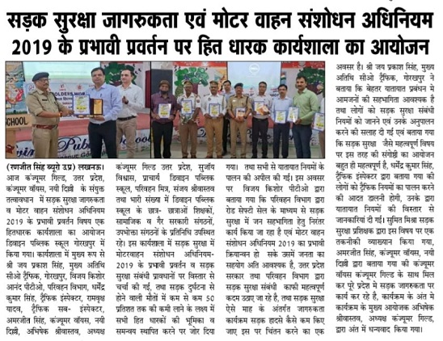
LUCKNOW SUPERFAST-

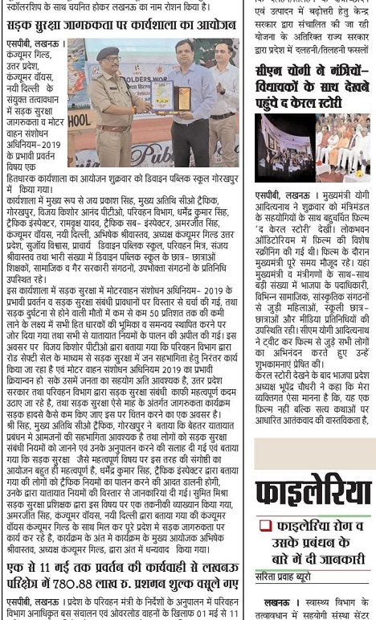
SARITA PRAVAH

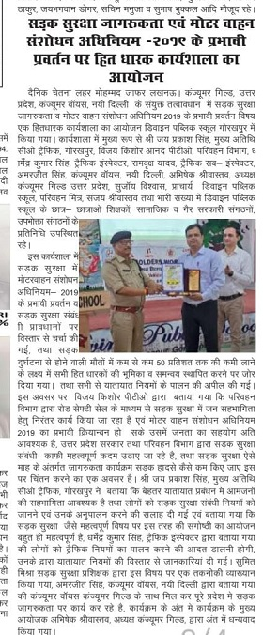
CHETNA LEHAR

