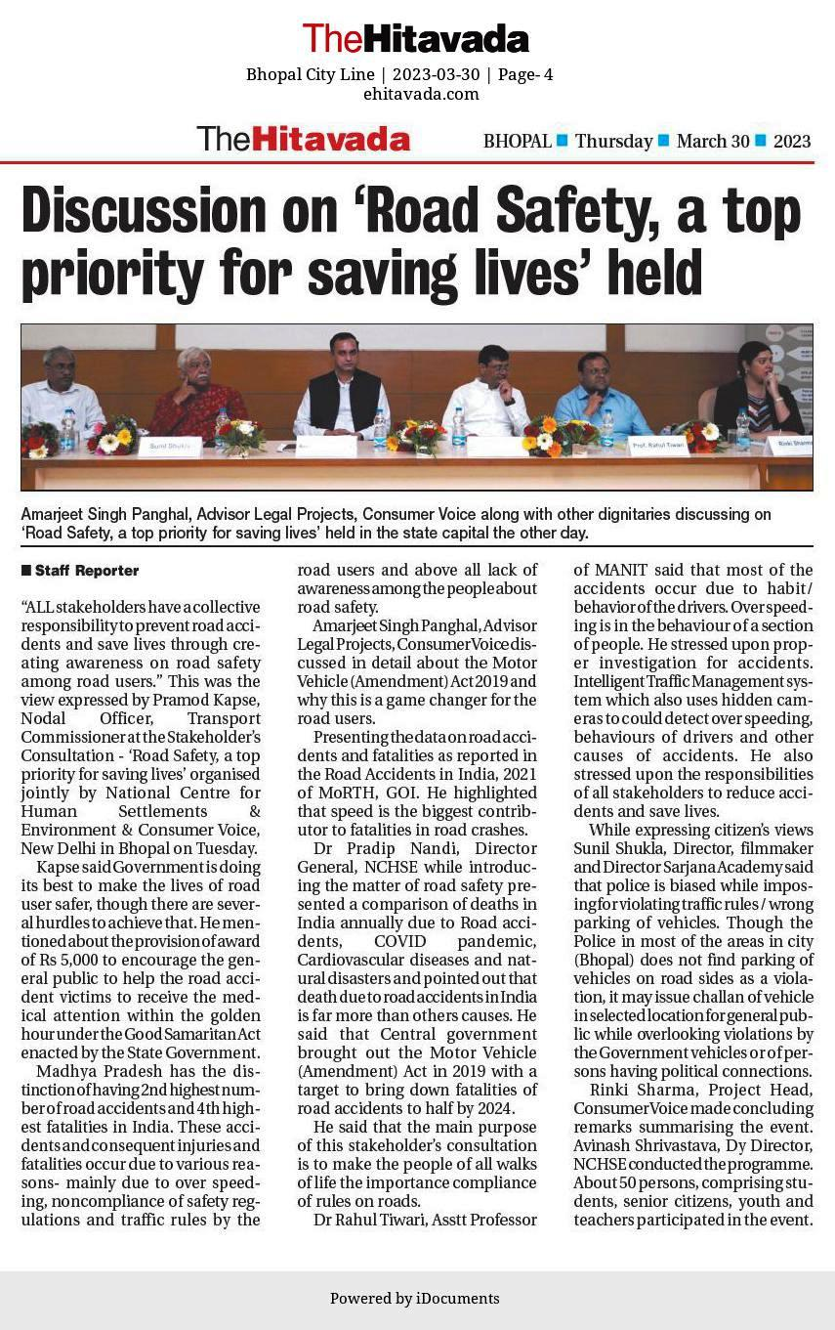
Media Reports -28th March -Stakeholders Consultation -Bhopal Madhya Pradesh
(1) The Hitavada
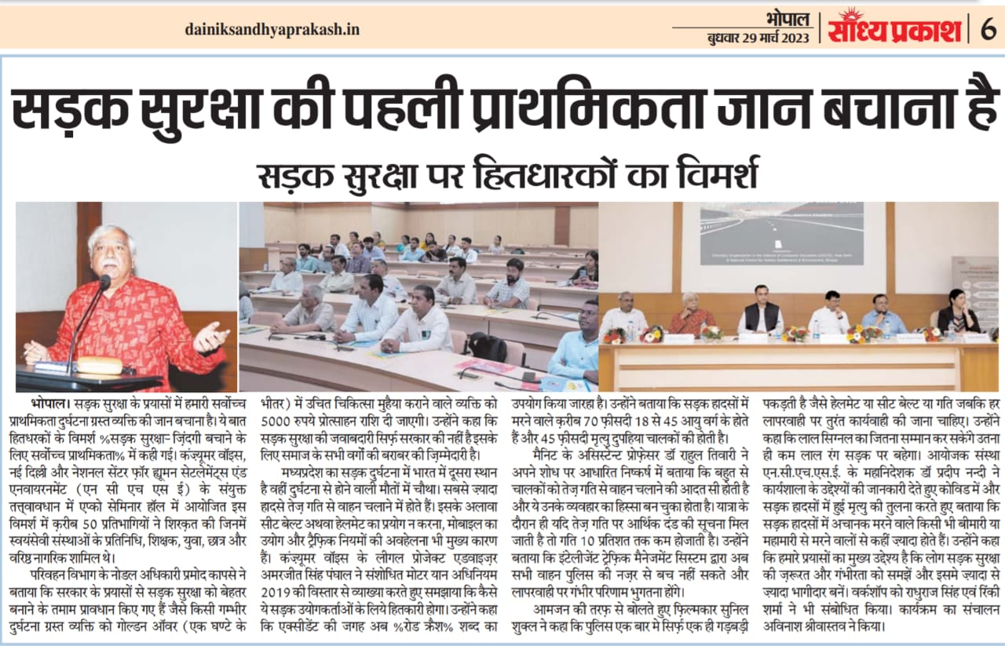
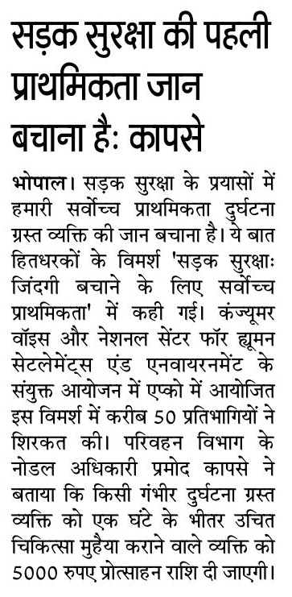
- Sandhya Prakash
(3) People’s Samachar

