Gujarat Media Coverage
Dhoraji Garjana News
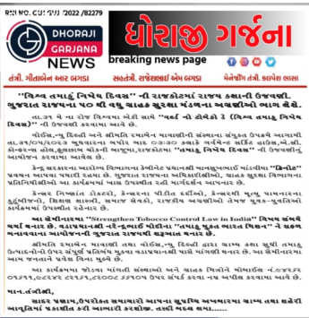

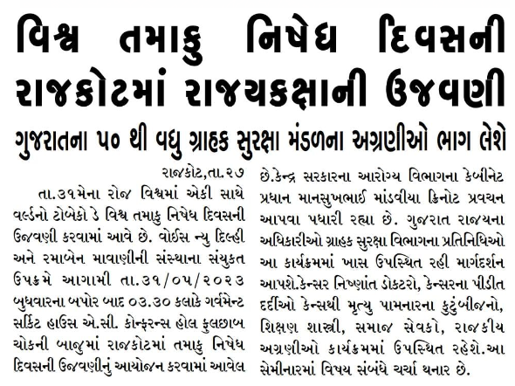
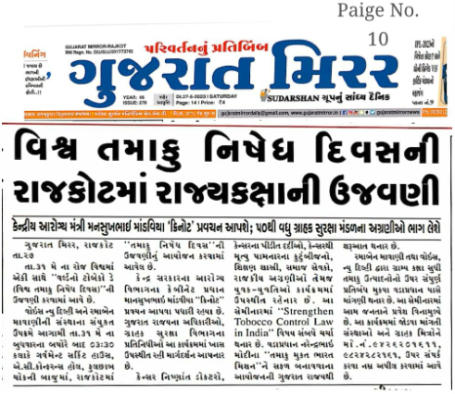

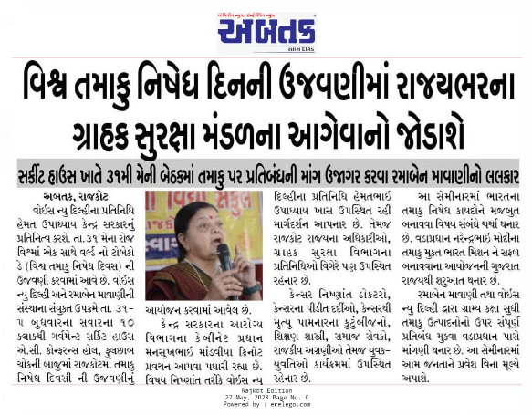

Gujarat post event

Abtak Media
An awareness seminar on the damage caused by tobacco was held today at World Tobacco Day, Circuit House
https://www.youtube.com/watch?v=2AB0tL2LwbQ

