Media Coverage Goa

Goa News Now
Live event link https://fb.watch/kSTRnur2Wm/?mibextid=CDWPTG

Live News Goa
VERNA INDUSTRIAL ASSOCIATION: ‘AWARENESS WALKATHON RALLY’ MARKS WORLD NO-TOBACCO DAY 2023
VERNA INDUSTRIAL ASSOCIATION: 'AWARENESS WALKATHON RALLY' MARKS WORLD NO-TOBACCO DAY 2023 - News for Positivity! | Latest English And Konkani News | Live News Goa TV | Goa's First & Only Positive News Channel

Goa News Hub
Anti-tobacco crusadors organize Awareness Walkathon Rally at Verna
https://livenewsgoa.com/verna-industrial-association-awareness-walkathon-rally-marks-world-no-tobacco-day-2023/

Zee business (You Tube)
Aapki Khabar Aapka Fayda: कैसे तंबाकू का सेवन हमारी सेहत के लिए जानलेवा है? देखिए ये चर्चा - YouTube
https://www.youtube.com/watch?v=6-PMnKyeq8s

Goa 365 TV (Youtube)
आनी वेर्णा इंडस्ट्रियल असोसिएशनन जागृताय रॅली घडोवन हाडली. Choose life and no tobacco - YouTube
https://www.youtube.com/watch?v=80YaPAub2j0&feature=youtu.be

Gomantak
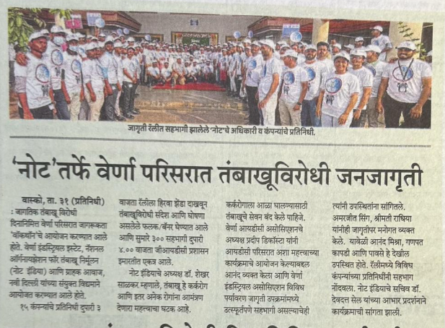

Lokmat Goa
