Madhya Pradesh (National Road Safety Week Coverage’s)
An interactive workshop was organised by NCHSE Bhopal Madhya Pradesh during road safety week at Ankur Higher Secondary School, New Market Bhopal on 17th Jan 2023.

Sandhya Prakash
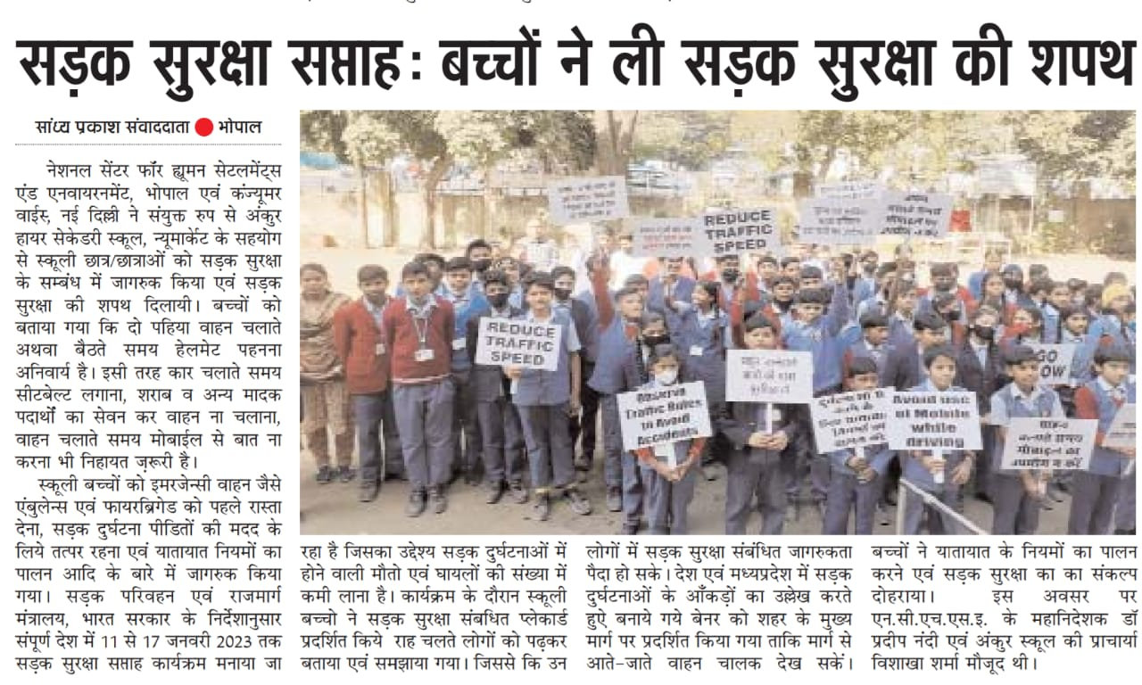
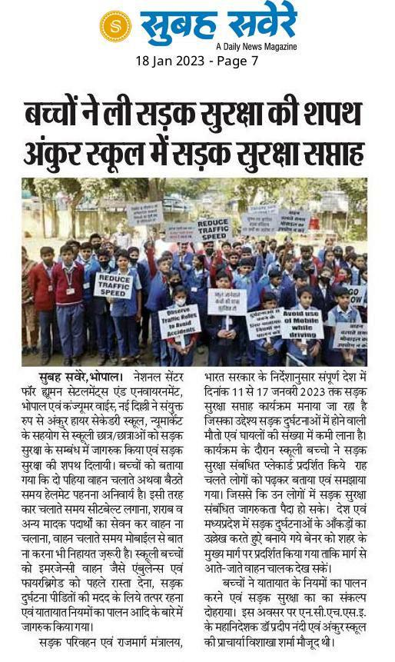

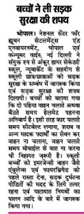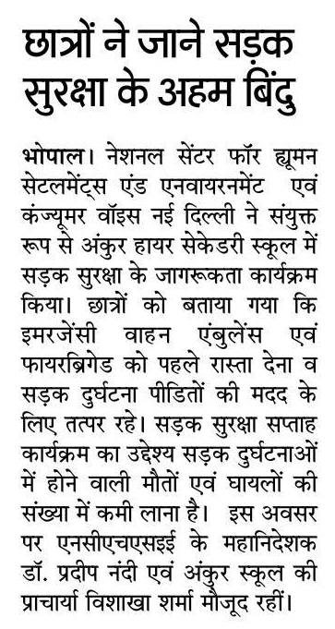
Dainik Nai Duniya

People's News

Uttar Pradesh Coverage’s (National Road Safety Week)

Consumer Guild, our state partner in the state of Uttar Pradesh organised an interactive meet and rally in the outskirts of Lucknow (rural area) on 14.01.2023 as a part of road safety week activities with support from Consumer VOICE New Delhi. Local coordination was done by Kiranoday foundation Uttar Pradesh.

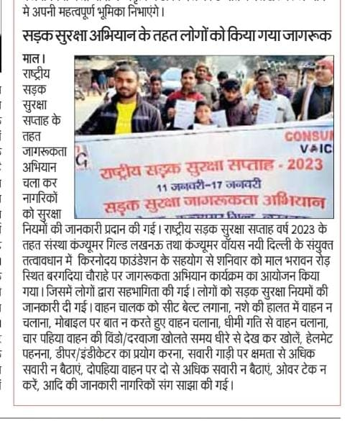 Uttar Pradesh News
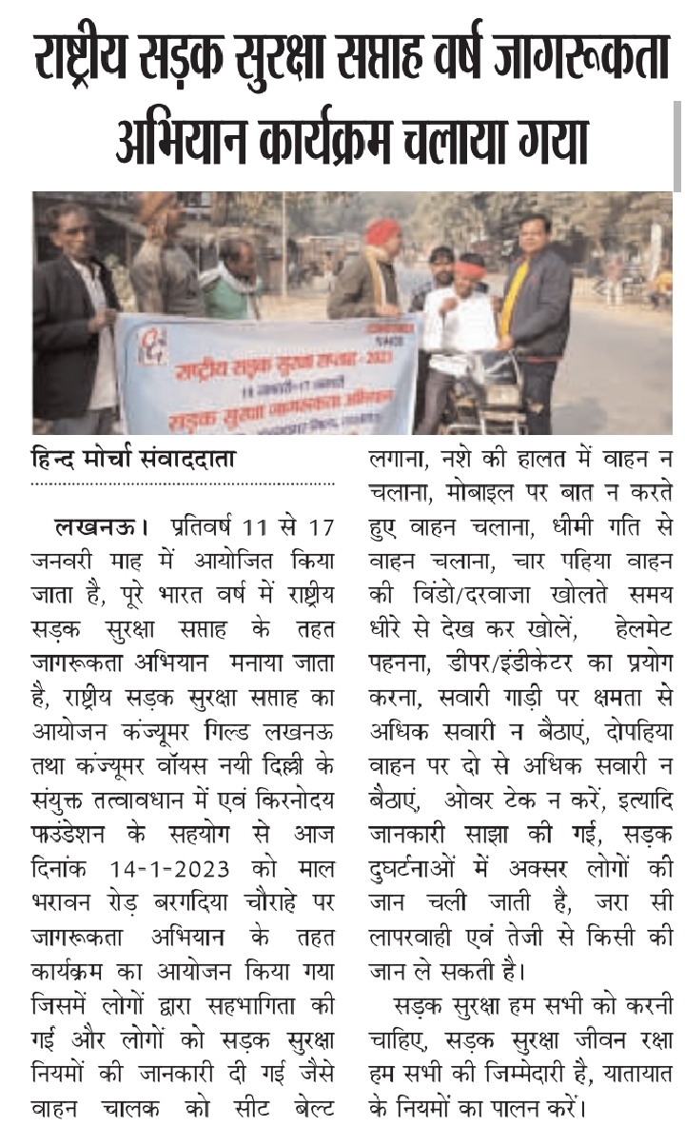 Hind Morcha

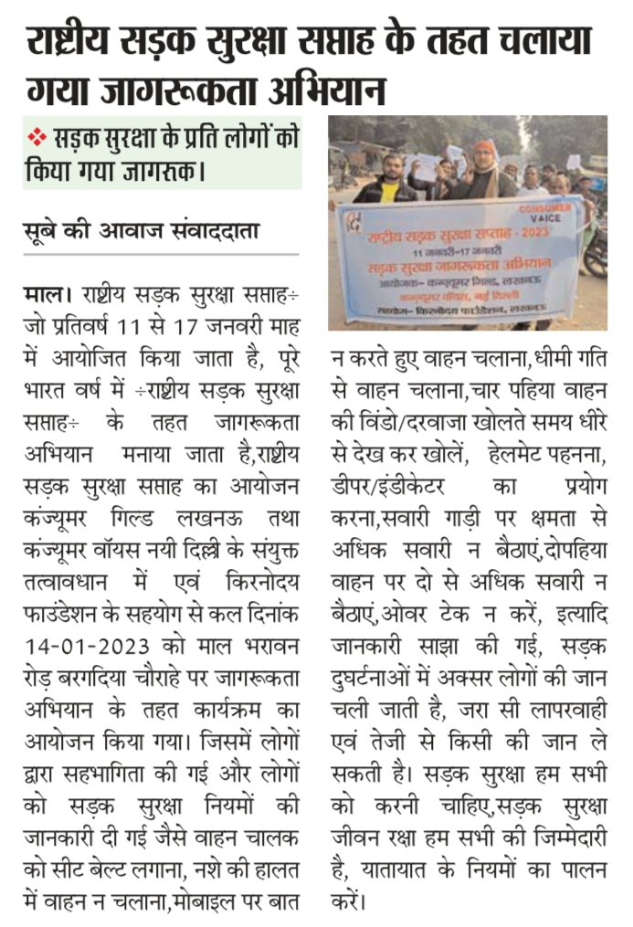Sube Ki Awaaz

