Road Safety Month - A road safety stakeholder’s workshop was organized by Consumer Guild, Uttar Pradesh with support from Consumer VOICE New Delhi on 21rd January 2023 at Gyan Udyan Inter College Kanpur Uttar Pradesh. Local coordination was done by Upbhokta Sashktikaran Kalyan Samiti (USKS ) Kanpur .The Purpose of the workshop was to strengthen road safety to save precious lives on roads by diligent enforcement.

Online Coverage’s:

1. https://www.charchachakra.page/2023/01/blog-post_21.html
2. http://m.rashtriyasahara.com/imageview_11182_126275000_4_5_22-01-2023_5_i_1_sf.html
3. https://newssamaytak.com/हितधारक-कार्यशाला-का-आयो/
Kanpur Mahanagar
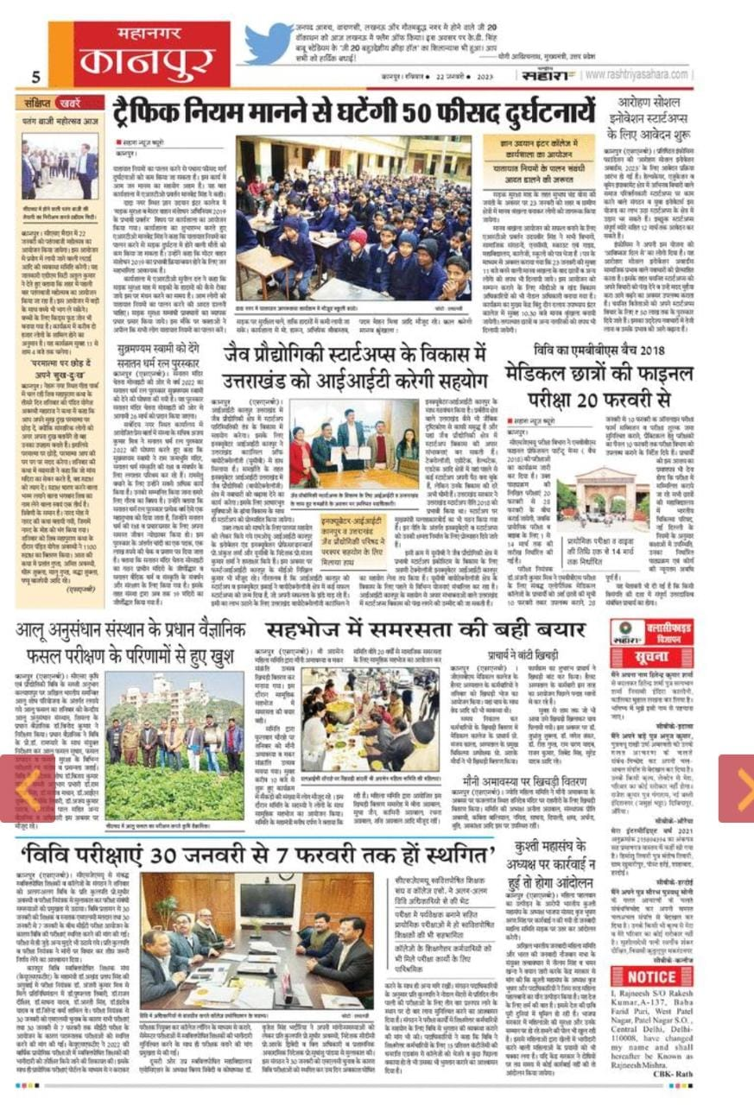

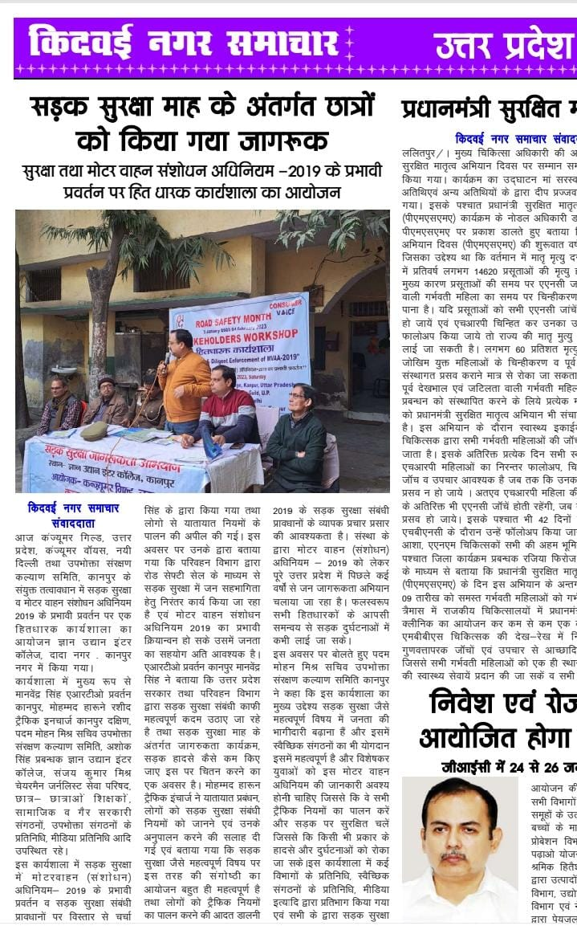

Mahanagar Kanpur

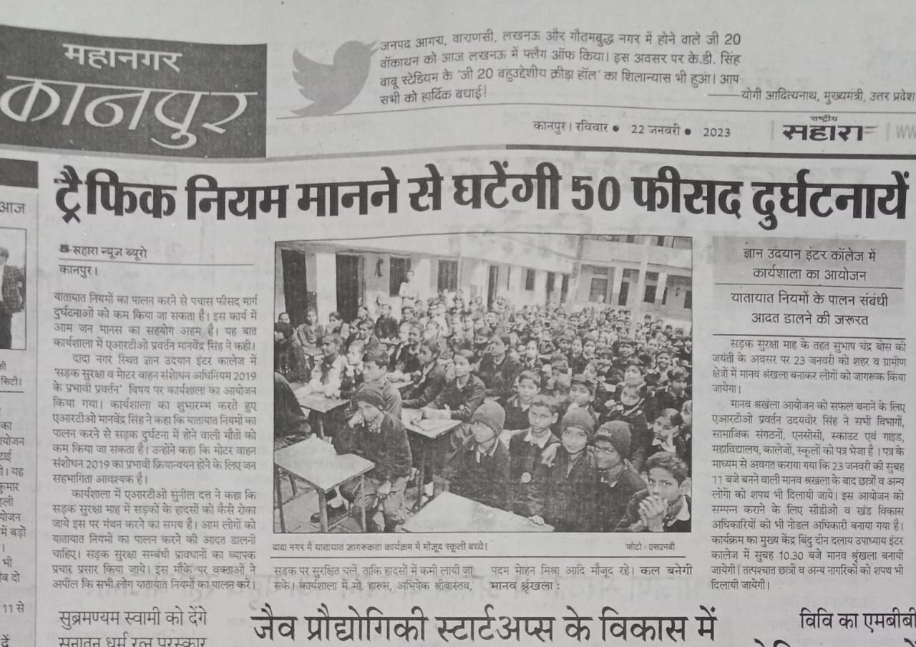

The Gram Today

