PRESS COVERAGE-World Day of Remembrance –Uttar Pradesh

HINDUSTAN

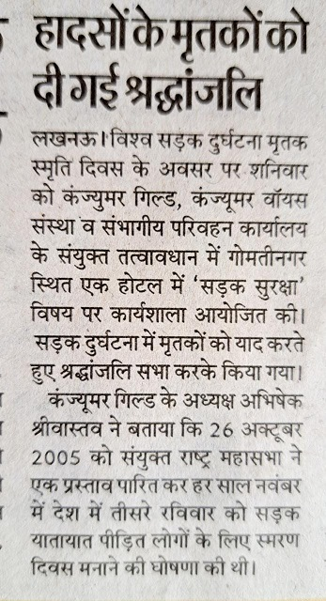

RASTRIYA SAHARA
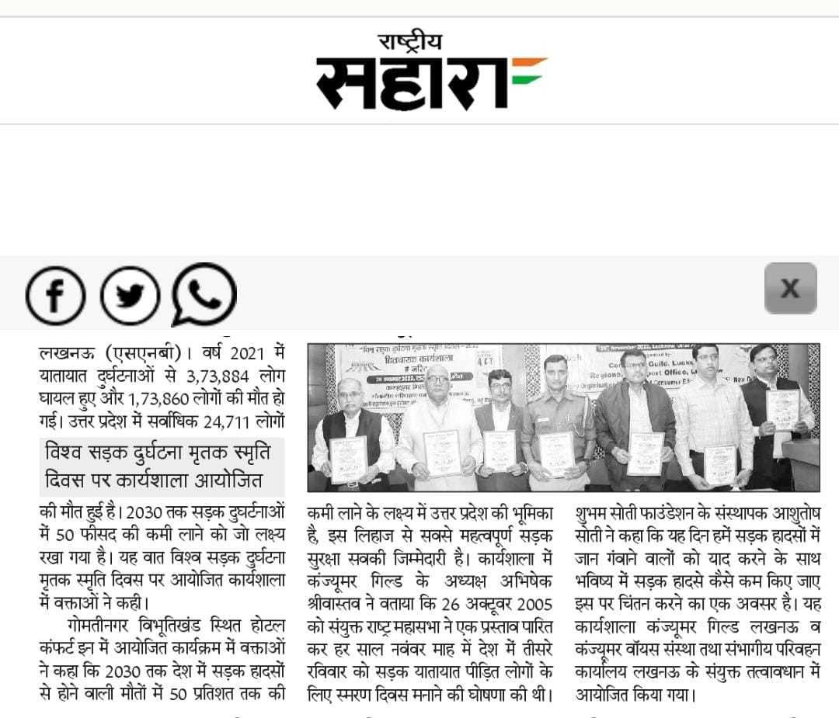

AMAR UJALA
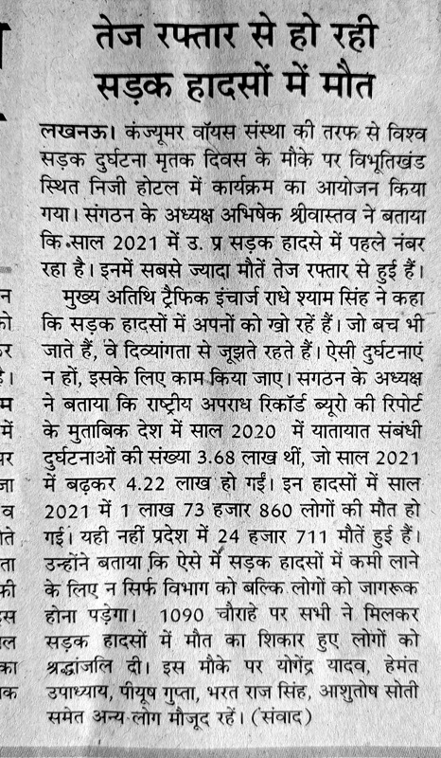

SHAURYA KESARI

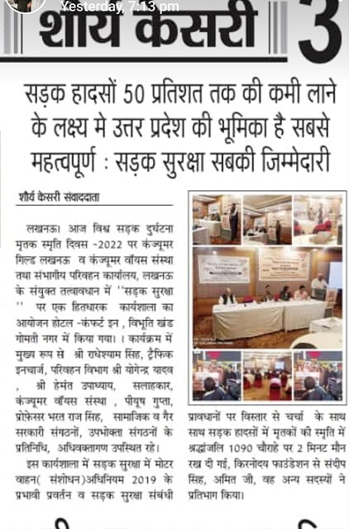

KHABAR DRISHTIKON
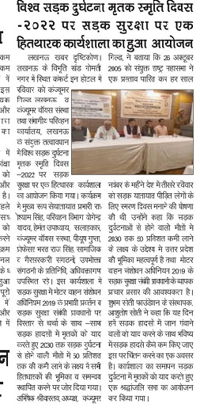

LUCKNOW SUPERFAST

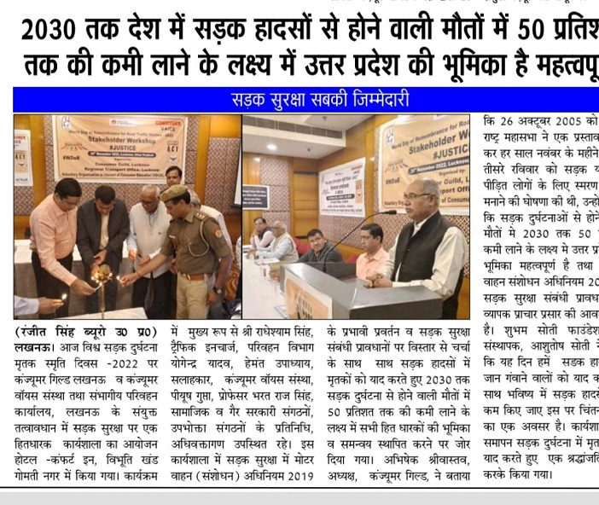

DAILY NEWS ACTIVIST

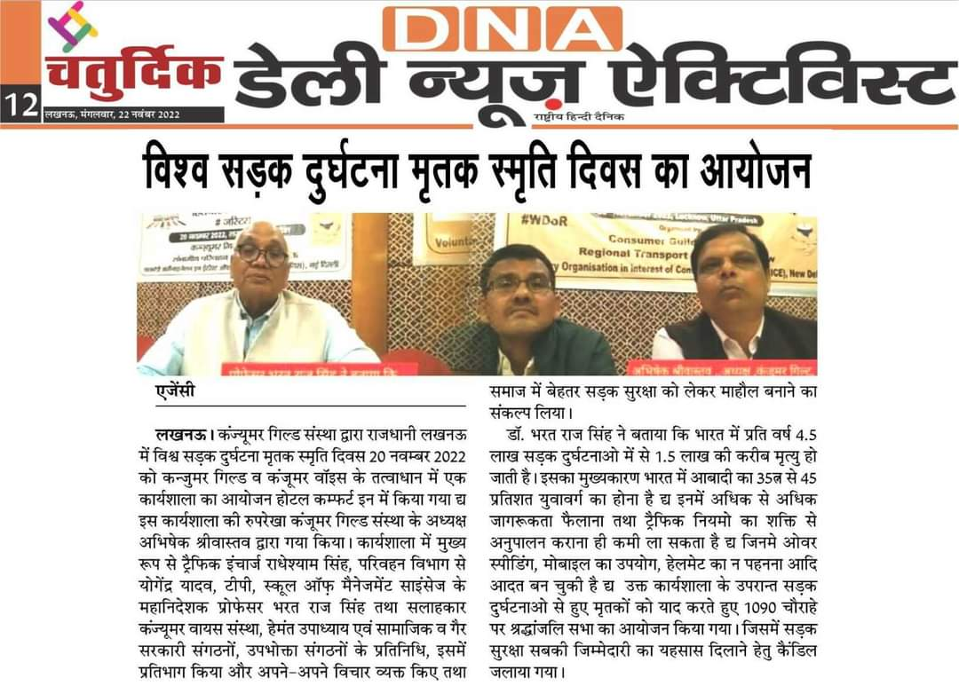
LOKMITRA
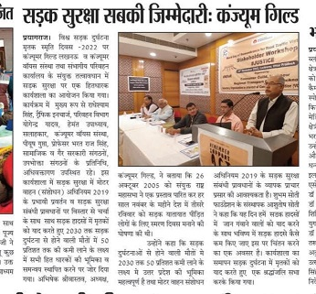

BIJNAUR TODAY
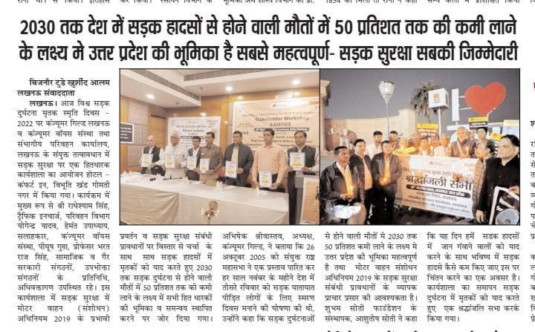

MOHAN DHARA
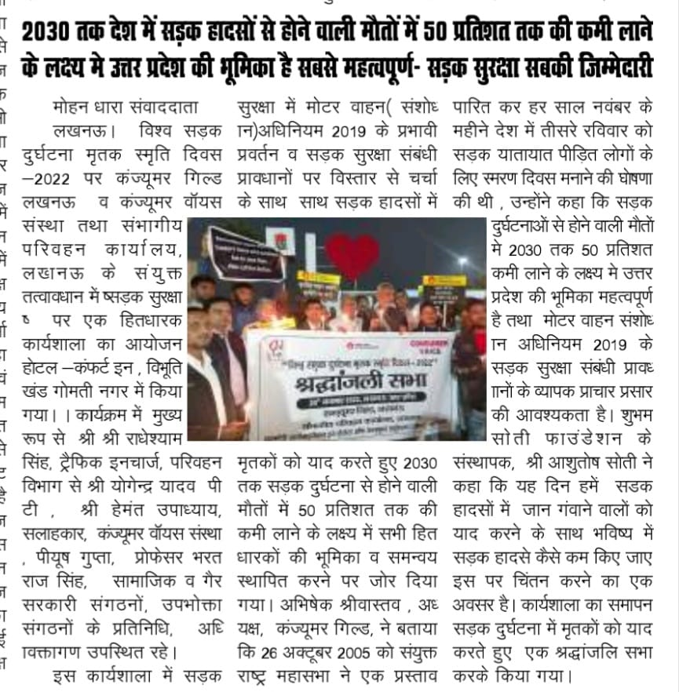

JANMAT TODAY
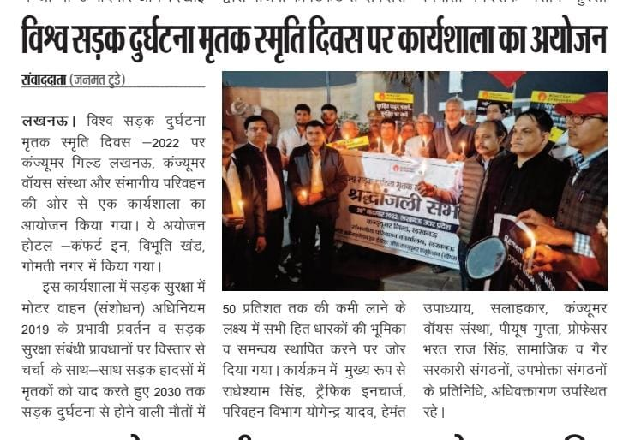
sherebalia

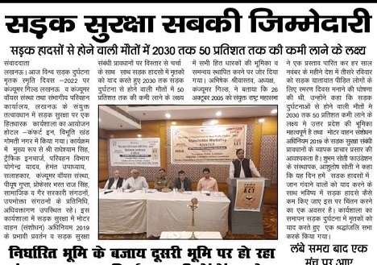

AMRIT VICHAR

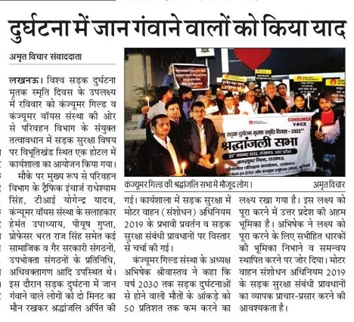

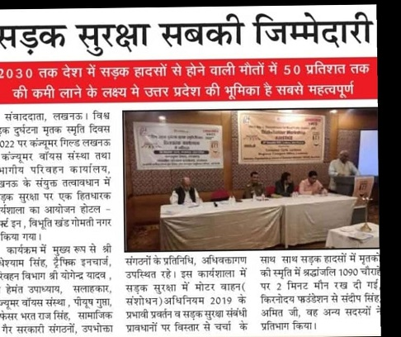
GHATNAYEIN DAILY

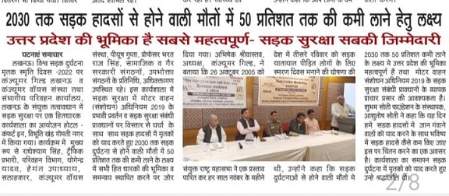

Electronic Media- ANI, UP SUPERFAST AND FEW LOCAL NEWS PORTALS ALSO COVERED THE WDR EVENT AT LUCKNOW.

