Sandhya Prakash
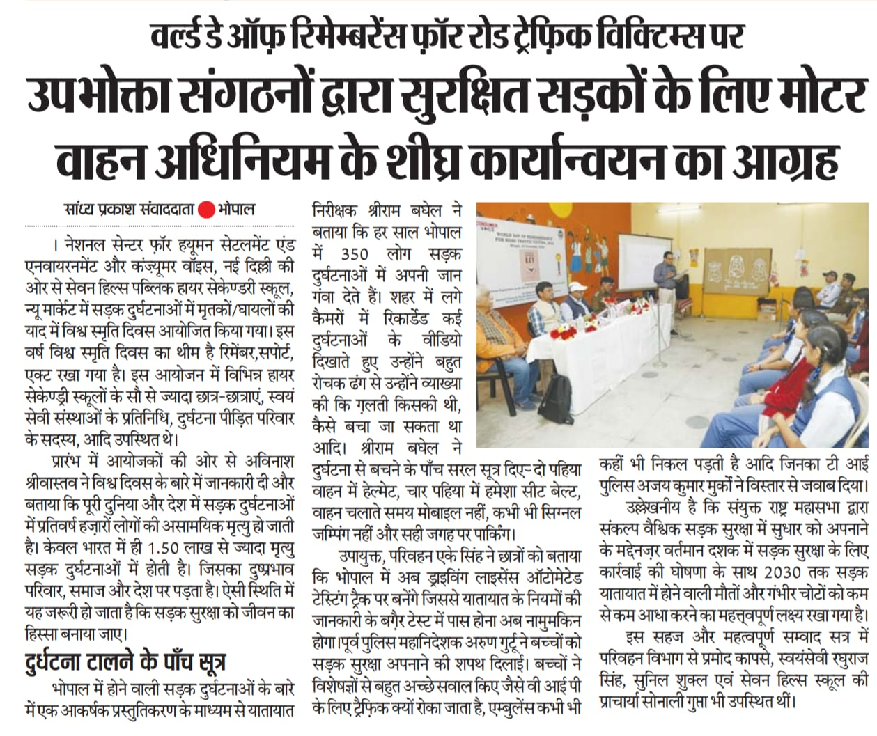
Subah Sabere
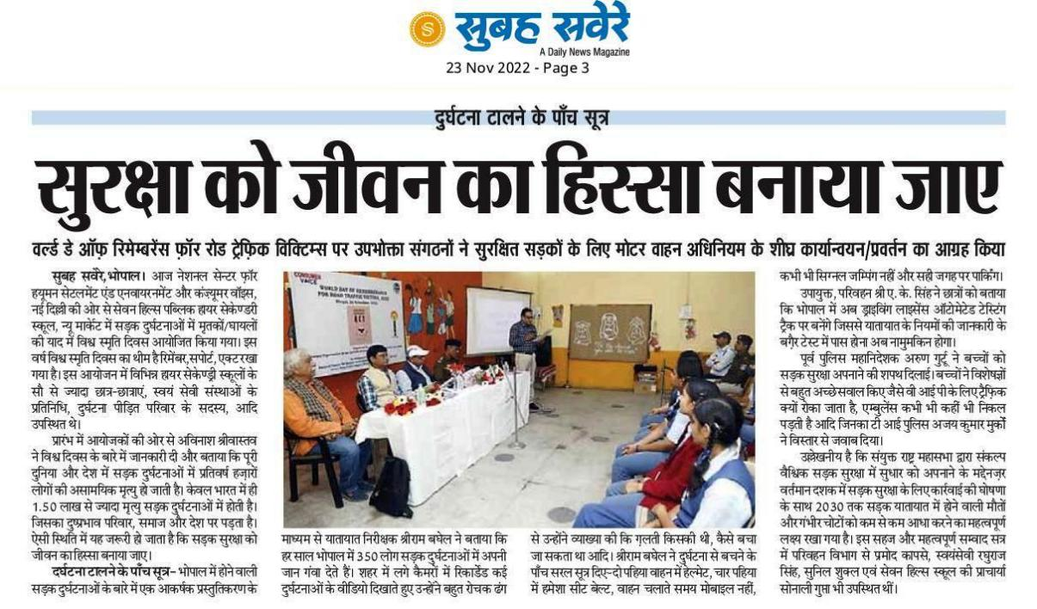

Navdunia
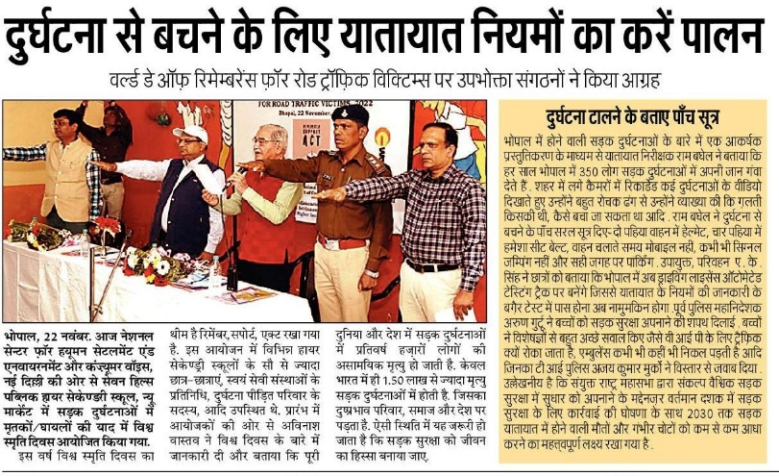

Free Press Journal

English News Paper -Free Press Journal
https://www.freepressjournal.in/bhopal/bhopal-why-is-traffic-stopped-for-vip-movement-ask-kids-at-workshop-on-road-traffic-victims

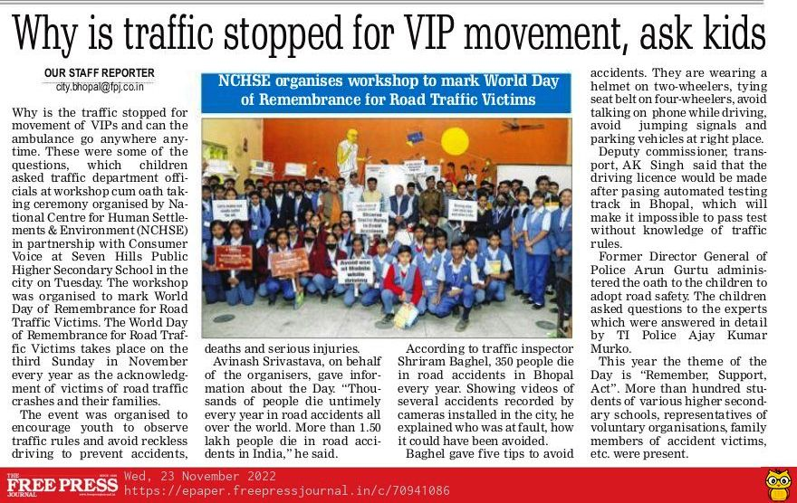
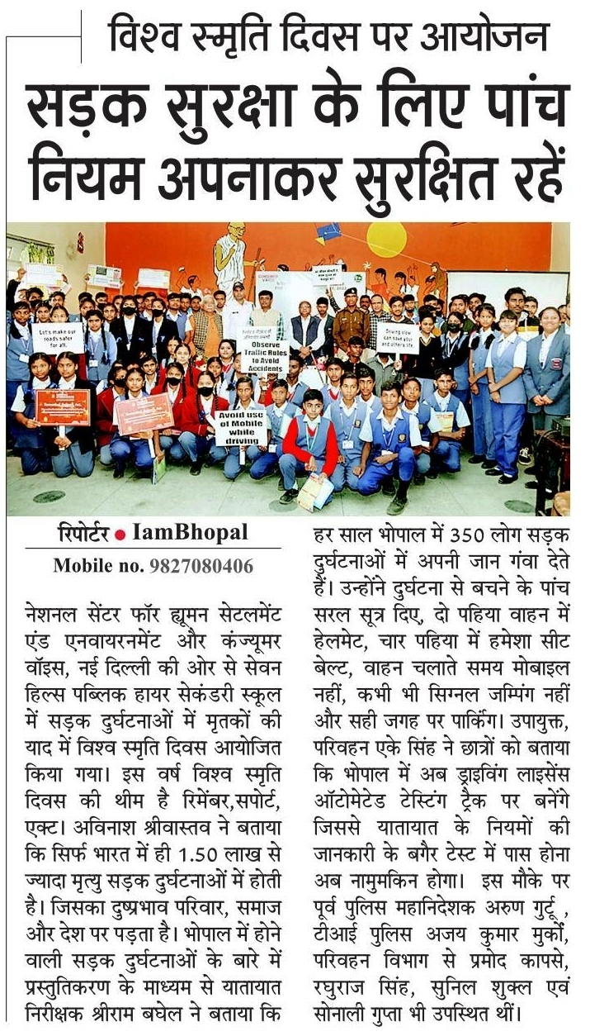
People’s Samachar

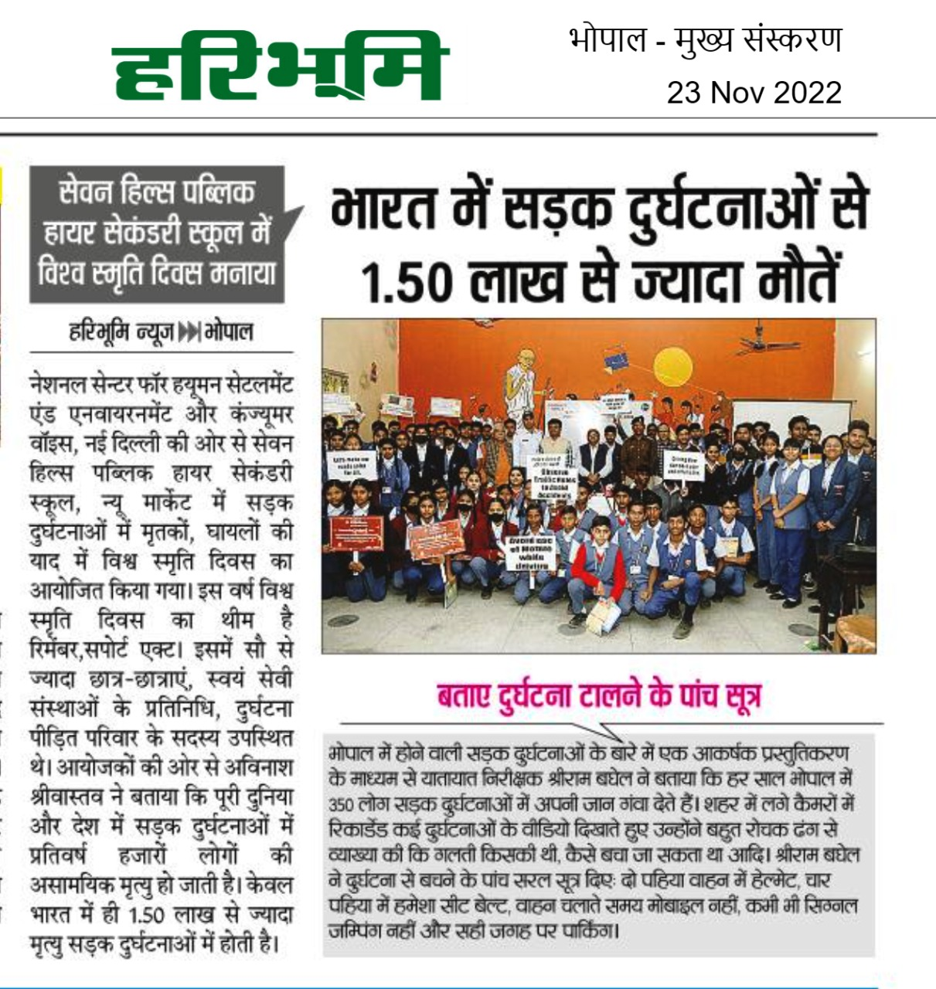
Haribhumi

Deshbandu

