Media Coverage – September 2021

Coverage based on Gujarat state specific press release on World Heart Day

29-Sep-21
Abatak daily
Unhealthy Diets, Foods with High Salt is the main cause of the Heart Diseases - Gujarat State is in Forefront for Heart Diseases - Caution is needed - Say Smt. Ramaben R. Mavani
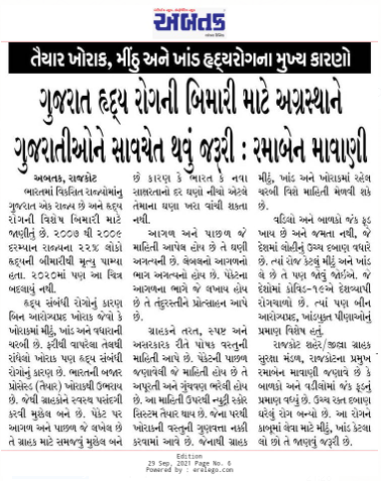

29-Sep-21
Gujarat Mirror
Now Gujarat is also tops in heart attack, Unhealthy Food, High Salt Food, Junk food is the main cause for Heart Attack
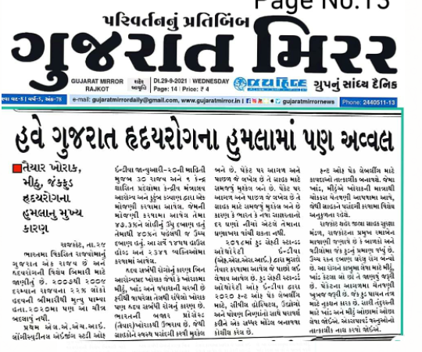

29-Sep-21
Aajkal daily
Gujarat state at the forefront of heart disease..caution is needed
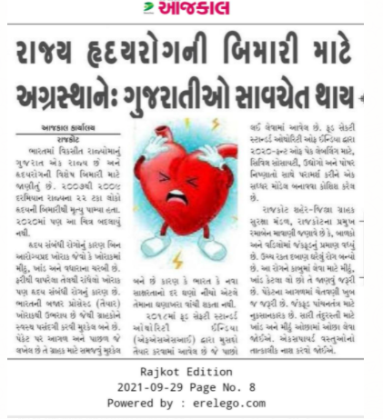

29-Sep-21
Akila daily
Gujarat State at the forefront of heart disease, Caution is needed for Gujarati
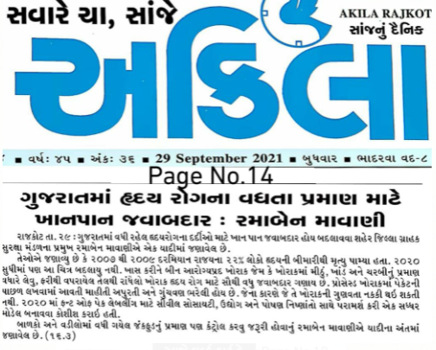

29-Sep-21
Sanj samachar
