WCRD 2020 – Media (Print & Online)
Print
Bhopal – Dainik Dabang Dunia
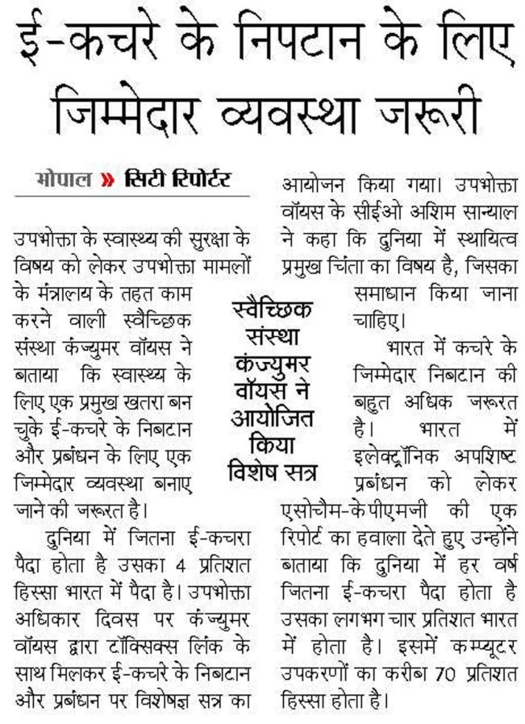

Online
PTI: India Needs Responsible Disposal and Management of E-waste for Sustainable Consumption: Consumer Voice: 17.3.2020
ANI: India Needs Responsible Disposal and Management of E-waste for Sustainable Consumption: Consumer Voice: 17.3.2020
UNI: India Needs Responsible Disposal and Management of E-waste for Sustainable Consumption: Consumer Voice: 17.3.2020
IANS: India Needs Responsible Disposal and Management of E-waste for Sustainable Consumption: Consumer Voice: 17.3.2020
https://www.aninews.in/news/business/india-needs-responsible-disposal-and-management-of-e-waste-for-sustainable-consumption-consumer-voice20200317160827/
https://www.indiatoday.in/pr-newswire?rkey=20200317EN54241&filter=4315
https://telanganatoday.com/pr-newswire?rkey=20200317EN54241&filter=11682
http://ians.in/index.php?param=prnewswiredetail/PRN-1067829
https://www.businesstoday.in/prnewswire/?rkey=20200317EN54241&filter=2418
http://www.ptinews.com/pressrelease/40127_press-subIndia-Needs-Responsible-Disposal-and-Management-of-E-waste-for-Sustainable-Consumption--Consumer-Voice
https://www.varindia.com/news/press--pr-news-wire?rkey=20200317EN54241&filter=537
http://www.uniindia.com/~/india-needs-responsible-disposal-and-management-of-e-waste-for-sustainable-consumption-consumer-voice/Business%20Economy/news/1920378.html
http://www.itnewsonline.com/prnewswire/India-Needs-Responsible-Disposal-and-Management-of-E-waste-for-Sustainable-Consumption-Consumer-Voice/683618
https://www.devdiscourse.com/article/business/941225-india-needs-responsible-disposal-and-management-of-e-waste-for-sustainable-consumption-consumer-voice
http://www.newsexperts.in/india-needs-responsible-disposal-management-e-waste-consumer-voice/
https://www.newznew.com/press-releases/?rkey=20200317EN54241&filter=16908
http://b-live.in/prnewswire-feeds/?rkey=20200317EN54241&filter=18861
http://www.biznews.in/article/india-needs-responsible-disposal-and-management-of-e-waste-for-sustainable-consumption-consumer-voice
https://businessfortnight.com/pr-newswire/?rkey=20200317EN54241&filter=5117
https://www.newdelhitimes.com/news-release/?rkey=20200317EN54241&filter=5147
http://www.smarttechtoday.com/prnews/?rkey=20200317EN54241&filter=2496
https://www.prativad.com/Newswireeng.php?rkey=20200317EN54241&filter=19411
https://www.pharmatutor.org/pharma-news/prnewswire?rkey=20200317EN54241&filter=7468
http://www.newsgram.com/press-releases/?rkey=20200317EN54241&filter=590
http://www.odisha360.com/prn/?rkey=20200317EN54241&filter=4962
https://news.indiaonline.in/prnewswire?rkey=20200317EN54241&filter=4991
http://corecommunique.com/prnewswire/?rkey=20200317EN54241&filter=4754
https://www.newsr.in/prnewswire.php?rkey=20200317EN54241&filter=5070
https://www.onenewspage.com/prnewswire.php?rkey=20200317EN54241&filter=3968
http://www.mangalorean.com/pr-newswire/?rkey=20200317EN54241&filter=17665
https://sambadenglish.com/prnews/?rkey=20200317EN54241&filter=4968
https://www.tmcnet.com/usubmit/-india-needs-responsible-disposal-management-e-waste-sustainable-/2020/03/17/9116062.htm
https://enterpriseworldnews.com/pr-newswire/?rkey=20200317EN54241&filter=19539
http://media.newswire.ca/newssuperfastblog.html?rkey=20200317EN54241&filter=10033
https://reviewstreet.in/news-reviews-mobiles-gadgets-pcs-automobile/prnewswireindia/?rkey=20200317EN54241&filter=15937
http://www.businesssandesh.in/breaking-news/?rkey=20200317EN54241&filter=7621
https://www.thesme.co.in/news-wire/?rkey=20200317EN54241&filter=18812
https://www.rnews1.com/p/pr-newswire.html?rkey=20200317EN54241&filter=7546
https://ibtn9.com/pr-newswire/?rkey=20200317EN54241&filter=12202
https://timestech.in/trends-forecast/?rkey=20200317EN54241&filter=15939
http://businessnewsthisweek.com/prnews/?rkey=20200317EN54241&filter=601
http://firstreport.in/pr-newswire/?rkey=20200317EN54241&filter=6490
http://www.thetimesofbengal.com/newswire/?rkey=20200317EN54241&filter=17730
https://windowtonews.com/pr-newswire-english.php?rkey=20200317EN54241&filter=19687
http://www.thehawk.in/news/prnewswire?rkey=20200317EN54241&filter=4853
http://nasheman.in/newswire/?rkey=20200317EN54241&filter=11016
http://indoredilse.com/english-news/?rkey=20200317EN54241&filter=10474
https://english.samajalive.in/pr-newswire/?rkey=20200317EN54241&filter=19527
http://www.bizwireexpress.com/showstoryPRN.php?rkey=20200317EN54241&filter=2276
http://odishanewstune.com/press-releases/?rkey=20200317EN54241&filter=19427
http://startuptostandout.com/pr-news-wire/?rkey=20200317EN54241&filter=17982
http://www.newscontrolroom.com/pr-newswire/?rkey=20200317EN54241&filter=19537
https://www.business-standard.com/article/news-ani/india-needs-responsible-disposal-and-management-of-e-waste-for-sustainable-consumption-consumer-voice-120031700920_1.html
https://www.newkerala.com/news/2020/44809.htm
https://epilogue.in/2020/03/17/india-needs-responsible-disposal-and-management-of-e-waste-for-sustainable-consumption-consumer-voice/
https://in.news.yahoo.com/india-needs-responsible-disposal-management-e-waste-sustainable-103826891.html
https://www.britishnewsnetwork.com/news/india-needs-responsible-disposal-and-management-of-e-waste-for-sustainable-consumption-consumer-voice20200317160826/
https://www.dkoding.in/press-release/india-needs-responsible-disposal-and-management-of-e-waste-for-sustainable-consumption-consumer-voice/

