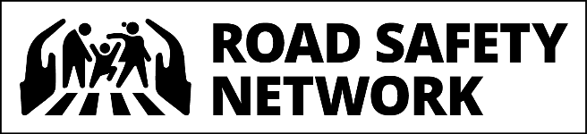
15th May 2020

PRESS NOTE
Road Safety Network submits recommendations to mitigate Road Crash Deaths during National Lockdown
New Delhi. National Road Safety Network, a coalition of leading road safety experts and organizations from across the country, today shared recommendations with the Home Secretary to ensure safe transit of migrants during the national lockdown. Road Crashes kill around 1,50,000 people every year and have continued to wreak havoc even during the national lockdown.
As part of the Road Safety Network, Consumer VOICE has been maintaining a ‘Road Crash Tracker’ to document road crash deaths and traffic violations during the lockdown from Mar 24th till date. So far, 1,176 road crashes with 321 fatalities have been documented.

“We have submitted a list of 15 recommendations to ensure the safety of migrants traveling on road. The recommendations are aimed at mitigating specific risk factors like speeding, driving while fatigued, overcrowding etc. Some of the recommendations are specifically towards the safety of migrant workers returning home” said, Ashim Sanyal, COO,Consumer VOICE organisation part of Road Safety Network.
“While we welcome the decision by the Ministry of Home Affairs (MHA) to run special trains and buses for ferrying migrants, students and stranded tourists to their hometowns, we remain concerned about the safety of drivers and passengers on journeys by road", said the letter addressed to the Union Home Secretary. Media reports indicate that driver fatigue combined with speeding has been responsible for the recent crashes.
In order to assist the Government of India to keep the road-users, especially passengers using the migrant bus services safe during these journeys the Road Safety Network has shared a set of safety protocols with the Government. The measures proposed include temporary lanes for cyclists and pedestrians on highways and urban roads, thorough briefing to bus drivers w.r.t emergency protocols, identifying rest areas where food and water can be provided to travellers, engaging drivers well-trained in long-distance driving and familiar with particular terrains.

Released on behalf of the Road Safety Network by:
Consumer VOICE
